# Lab 5: Firewall Exploration

Student ID: 1004885

Name: Guo Yuchen

## Task 1: Implementing a Simple Firewall

### Task 1.A: Implement a Simple Kernel Module

Make and load the hello.ko module:

$ sudo insmod hello.ko   
$ lsmod | grep hello   
$ dmesg

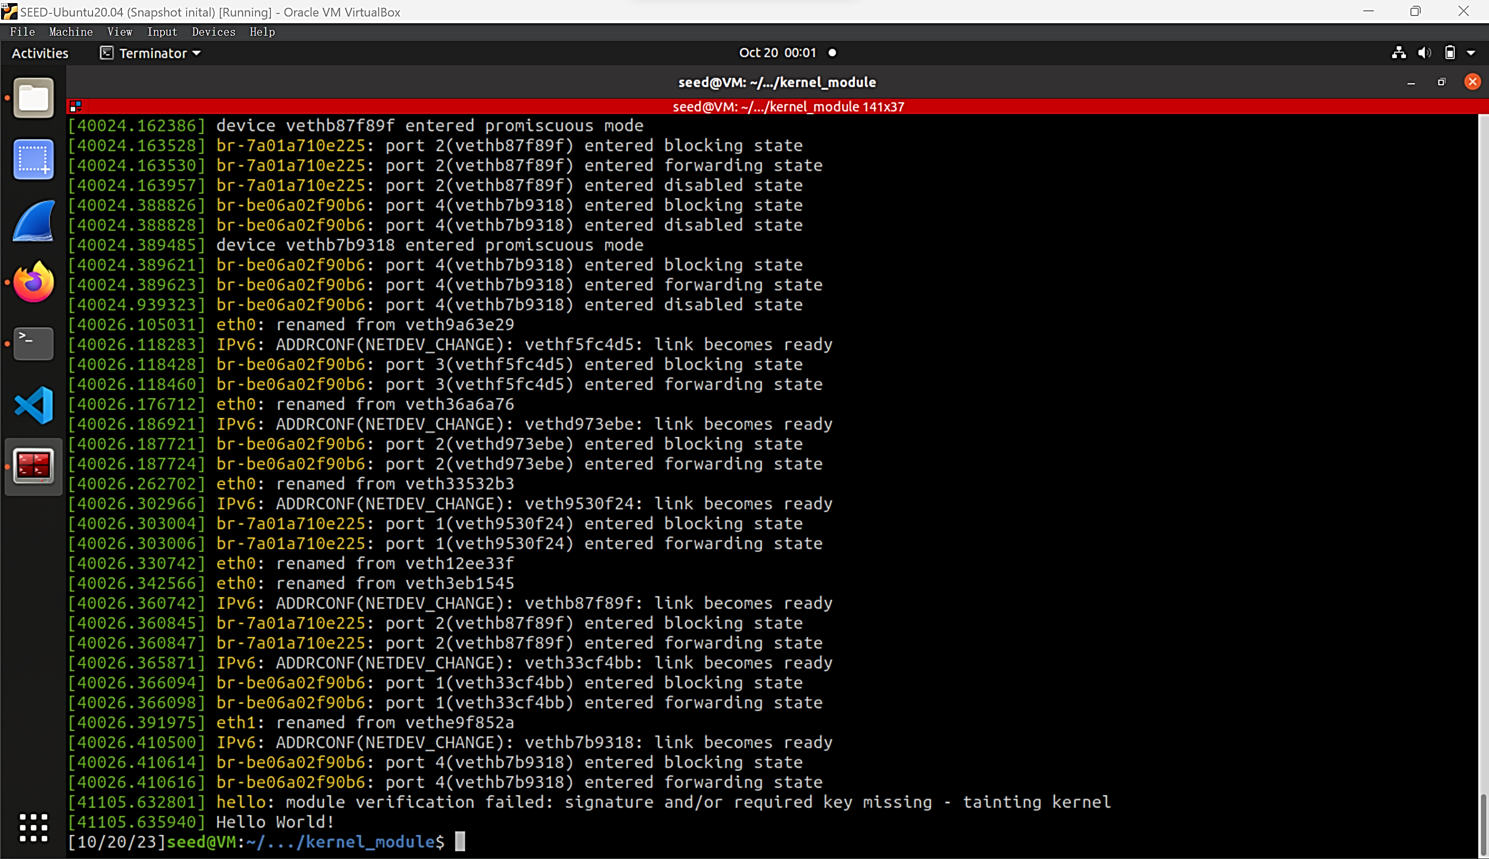

### Task 1.B: Implement a Simple Firewall Using Netfilter

#### Task 1

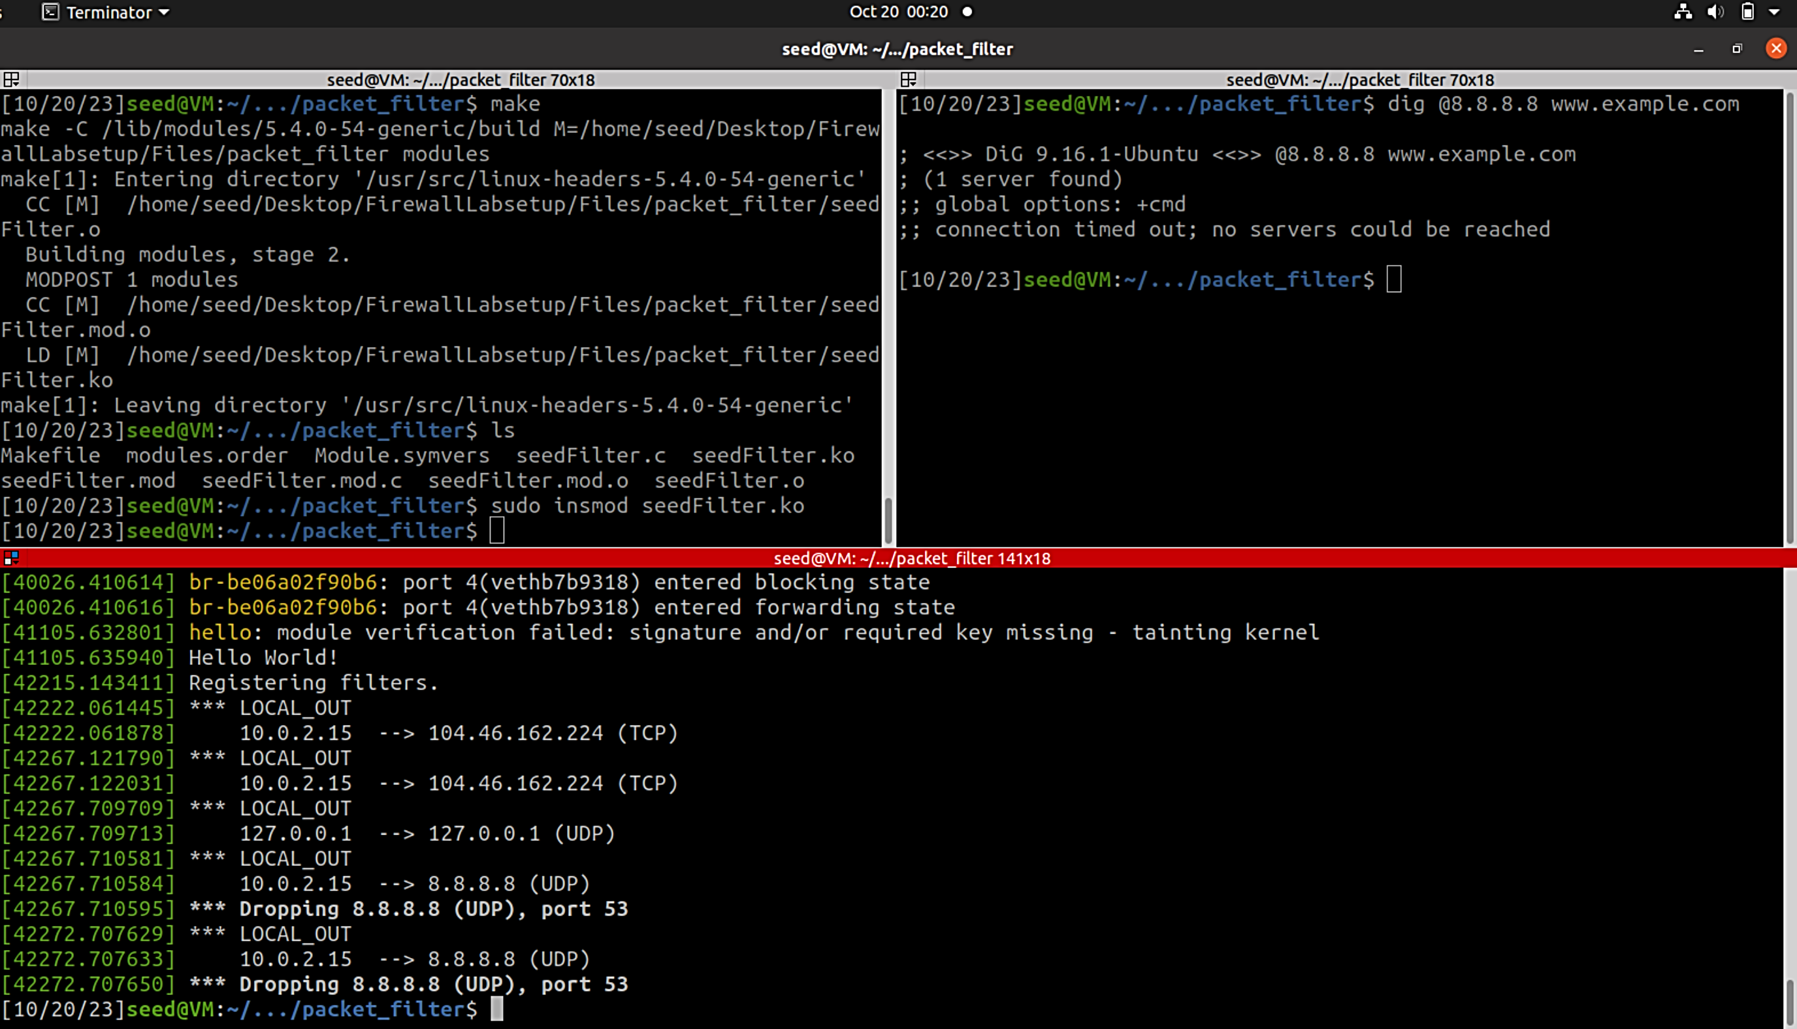

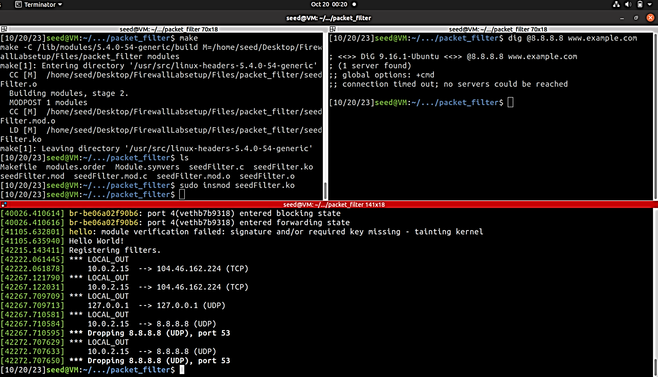

Request is blocked, since all DNS packages which goes to 8.8.8.8 are dropped.

#### Task2

Apply printInfo function to all hooks:

Int **registerFilter**(**void**){

// omit previous hooks…

hook3.hook = printInfo;  
 hook3.hooknum = NF_INET_PRE_ROUTING;  
 hook3.pf = PF_INET;  
 hook3.priority = NF_IP_PRI_FIRST;  
 nf_register_net_hook(&init_net, &hook3);  
  
 hook4.hook = printInfo;  
 hook4.hooknum = NF_INET_LOCAL_IN;  
 hook4.pf = PF_INET;  
 hook4.priority = NF_IP_PRI_FIRST;  
 nf_register_net_hook(&init_net, &hook4);  
  
 hook5.hook = printInfo;  
 hook5.hooknum = NF_INET_FORWARD;  
 hook5.pf = PF_INET;  
 hook5.priority = NF_IP_PRI_FIRST;  
 nf_register_net_hook(&init_net, &hook5);  
  
 hook6.hook = printInfo;  
 hook6.hooknum = NF_INET_POST_ROUTING;  
 hook6.pf = PF_INET;  
 hook6.priority = NF_IP_PRI_FIRST;  
 nf_register_net_hook(&init_net, &hook6);

}

After dig @8.8.8.8 www.example.com:

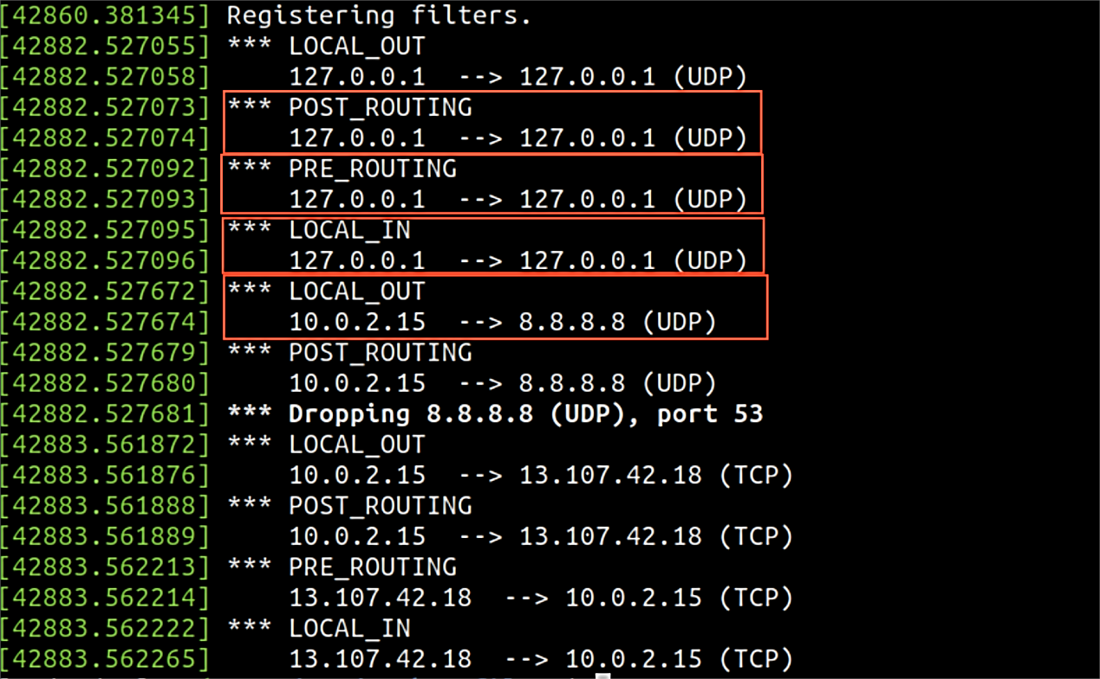

Under what condition will each of the hook function be invoked:

* NF_INET_PRE_ROUTING: when a packet is received by the network stack, before the routing decision is made.
* NF_INET_LOCAL_IN: when a packet is about to be delivered locally (the packet's destination IP address matches one of the local system's interfaces). It happens after routing decisions have been made but before any local processing takes place.
* NF_INET_FORWARD: when a packet is to be forwarded through the system.
* NF_INET_LOCAL_OUT: when a locally generated packet is about to leave the system.
* NF_INET_POST_ROUTING: before a packet is sent out on a network interface.

#### Task3

Implement two more hooks

// preventing other computers to ping the VM  
unsigned **int** **blockPing**(**void** *priv, **struct** sk_buff *skb,  
 **const** **struct** nf_hook_state *state)  
{  
 **struct** iphdr *iph;  
 **struct** icmphdr *icmph;  
  
 **if** (!skb)  
 **return** NF_ACCEPT;  
  
 iph = ip_hdr(skb);  
 icmph = icmp_hdr(skb);  
  
 **if** (icmph->type == ICMP_ECHO)  
 {  
 printk(KERN_WARNING "* Dropping %pI4 (ICMP_ECHO)\n", &(iph->daddr));  
 **return** NF_DROP;  
 }  
 **return** NF_ACCEPT;  
}  
  
// preventing other computers to telnet into the VM  
// Telnet’s default port is TCP port 23.  
unsigned **int** **blockTelnet**(**void** *priv, **struct** sk_buff *skb,  
 **const** **struct** nf_hook_state *state)  
{  
 **struct** iphdr *iph;  
 **struct** tcphdr *tcph;  
  
 u16 port = 23;  
  
 **if** (!skb)  
 **return** NF_ACCEPT;  
  
 iph = ip_hdr(skb);  
  
 **if** (iph->protocol == IPPROTO_TCP)  
 {  
 tcph = tcp_hdr(skb);  
 **if** (ntohs(tcph->dest) == port)  
 {  
 printk(KERN_WARNING "* Dropping %pI4 (TCP), port %d\n", &(iph->daddr), port);  
 **return** NF_DROP;  
 }  
 }  
 **return** NF_ACCEPT;  
}

Int **registerFilter**(**void**){   
 // omit previous hooks…  
 // (1) preventing other computers to ping the VM  
 hook7.hook = blockPing;  
 hook7.hooknum = NF_INET_LOCAL_IN;  
 hook7.pf = PF_INET;  
 hook7.priority = NF_IP_PRI_FIRST;  
 nf_register_net_hook(&init_net, &hook7);  
  
 // (2) preventing other computers to telnet into the VM.  
 hook8.hook = blockTelnet;  
 hook8.hooknum = NF_INET_LOCAL_IN;  
 hook8.pf = PF_INET;  
 hook8.priority = NF_IP_PRI_FIRST;  
nf_register_net_hook(&init_net, &hook8);  
}

ping 10.9.0.1 from 10.9.0.5 -> could not connect

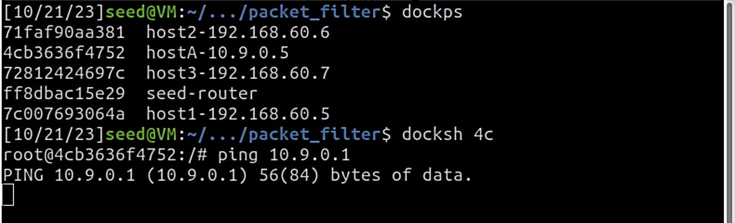

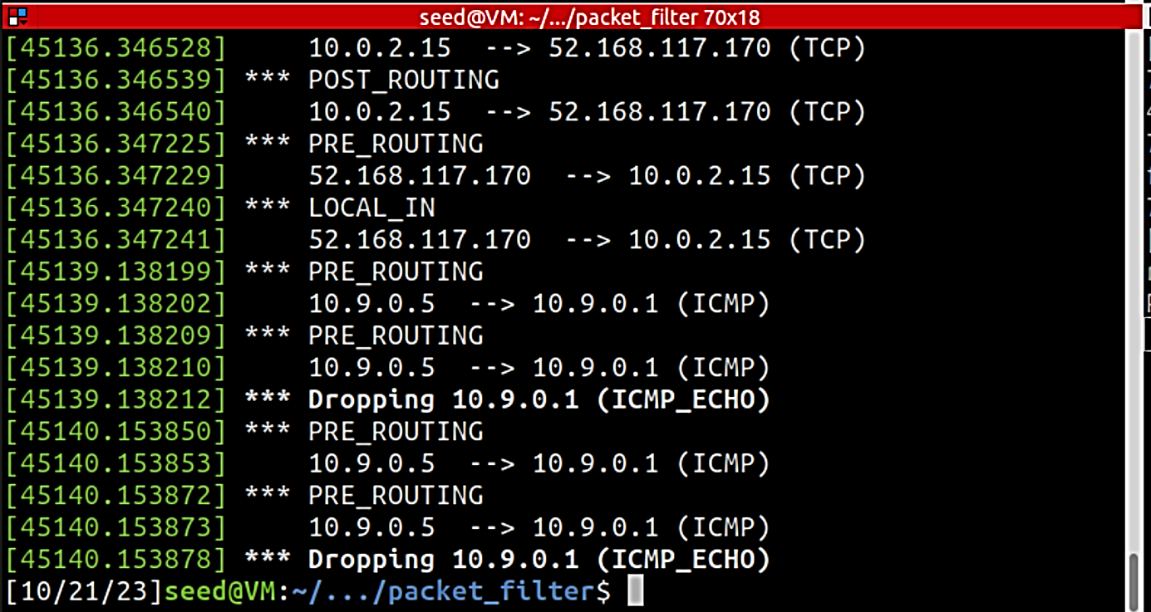

telnet 10.9.0.1 from 10.9.0.5 -> could not connect

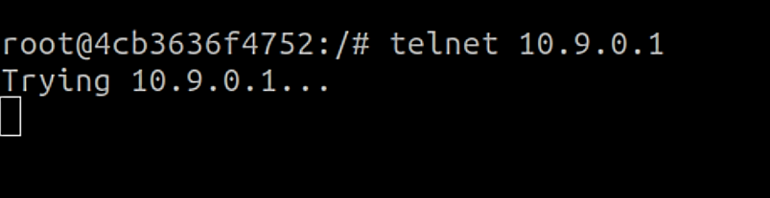

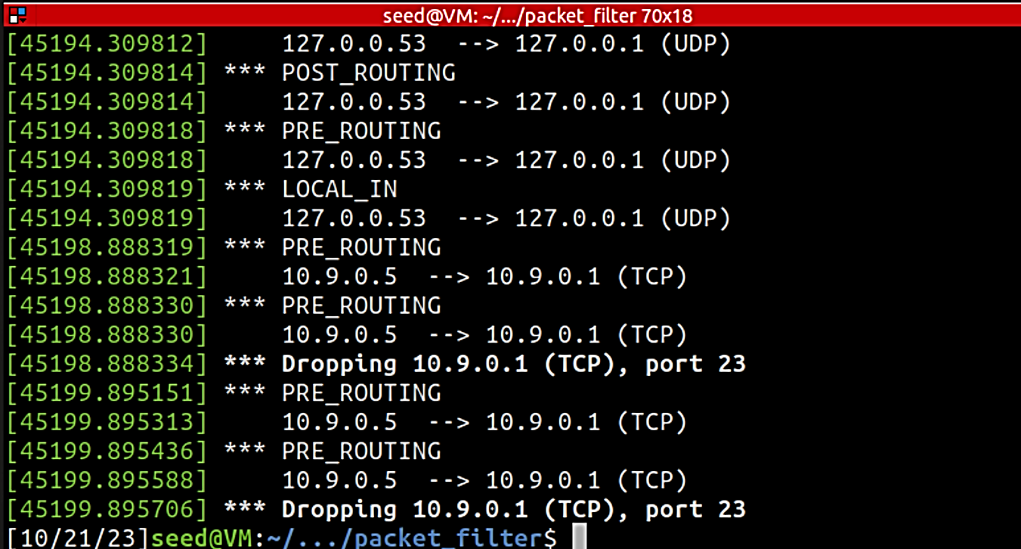

## Task 2: Experimenting with Stateless Firewall Rules

### Task 2.A: Protecting the Router

**// Append a rule in the INPUT chain to accept all icmp echo-request packets.**   
iptables -A INPUT -p icmp --icmp-type echo-request -j ACCEPT  
**// Append a rule in the OUTPUT chain to accept all icmp echo-reply packets.**iptables -A OUTPUT -p icmp --icmp-type echo-reply -j ACCEPT  
**// Set default policy for OUTPUT**iptables -P OUTPUT DROP  
**// Set default policy for INPUT**iptables -P INPUT DROP

Before applying rule:

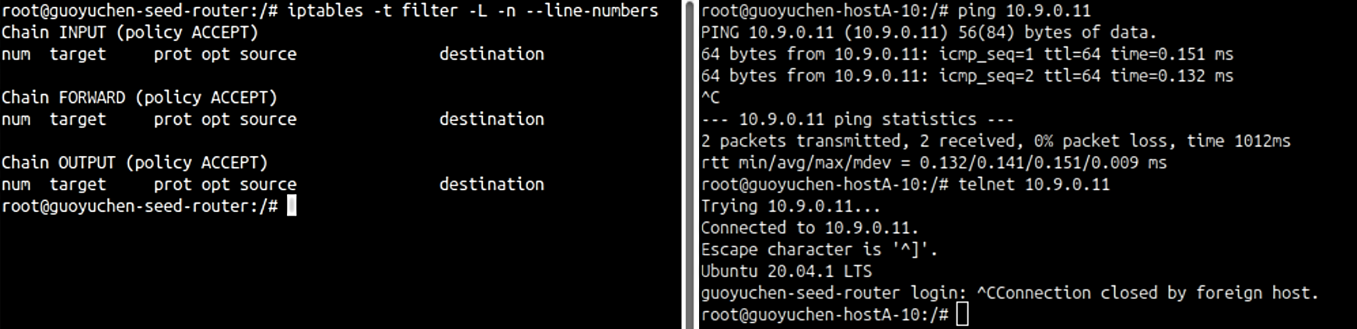



Both ping and telnet can connect.

Implement rules:

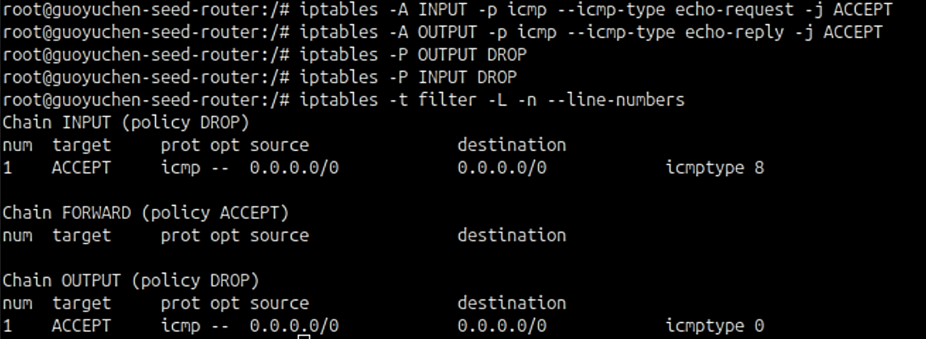

Can ping

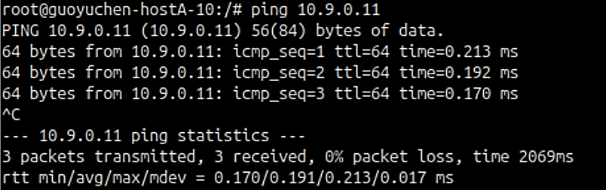

Cannot telnet

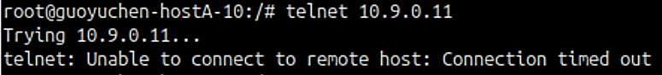

### Task 2.B: Protecting the Internal Network

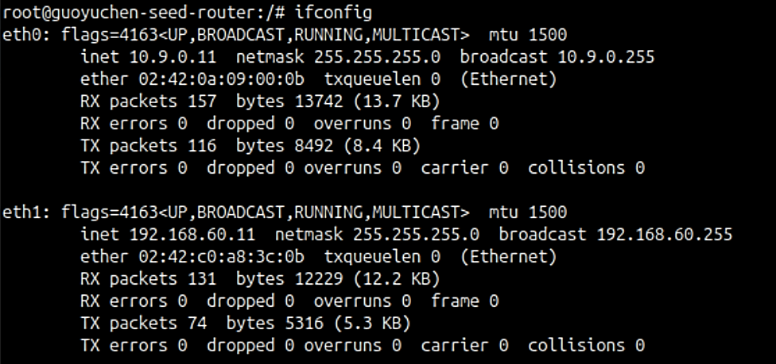

Thus out-interface: eth0, in-interface: eth1

**// Outside hosts cannot ping internal hosts. All icmp echo request packages from eth0 will be dropped.**iptables -A FORWARD -i eth0 -p icmp --icmp-type echo-request -j DROP  
  
**// Outside hosts can ping the router. All icmp echo request packages from eth0 to the router will be accepted.**iptables -A FORWARD -i eth1 -d 10.9.0.11 -p icmp --icmp-type echo-request -j ACCEPT  
  
**// Internal hosts can ping outside hosts. All icmp echo request packages from eth1 and icmp echo reply packages from eth0 will be accepted.**iptables -I FORWARD -i eth1 -o eth0 -p icmp --icmp-type echo-request -j ACCEPT  
iptables -I FORWARD -i eth0 -o eth1 -p icmp --icmp-type echo-reply -j ACCEPT  
  
**// All other packets between the internal and external networks should be dropped.**iptables -P FORWARD DROP

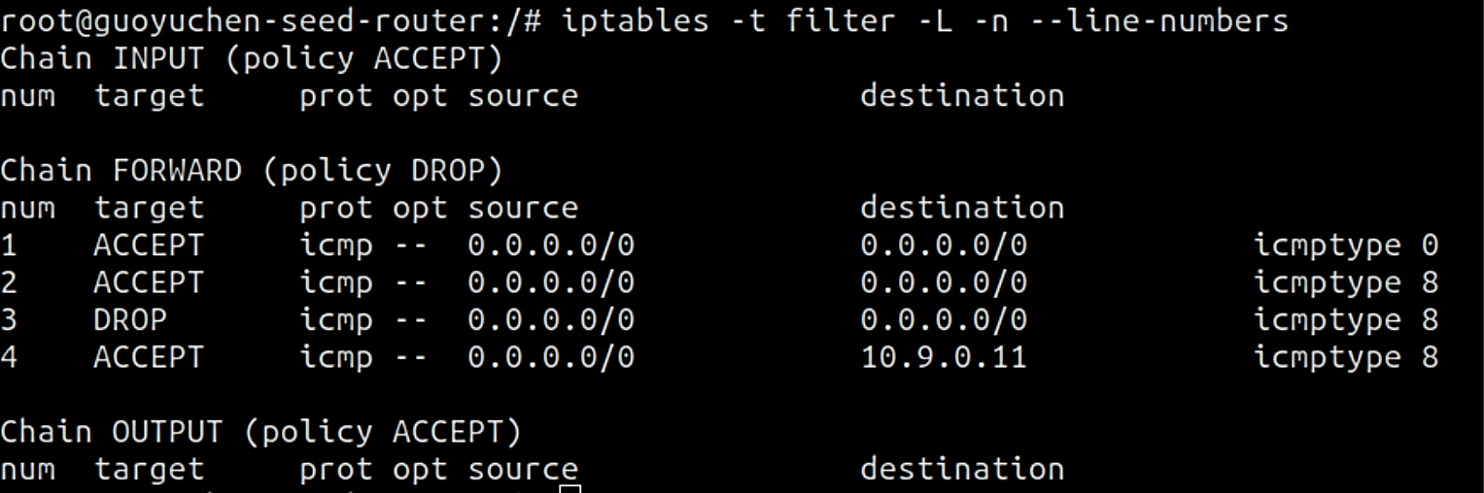

* Outside hosts cannot ping internal hosts.

From 10.9.0.5

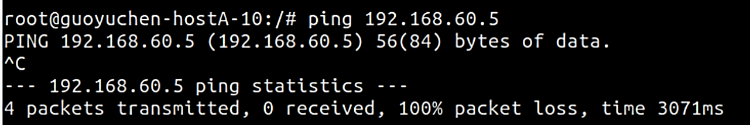

* Outside hosts can ping the router.

From 10.9.0.5

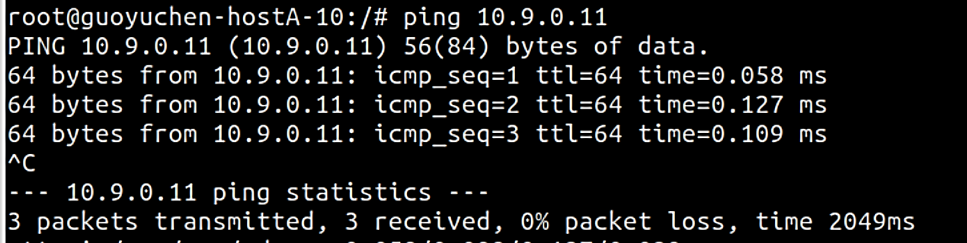

* Internal hosts can ping outside hosts.

From host1-192.168.60.5

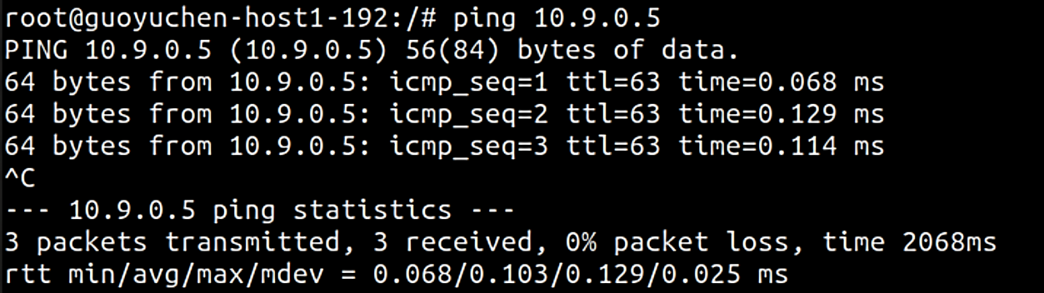

* All other packets between the internal and external networks should be blocked.

telnet from 10.9.0.5 to 192.168.60.5 is blocked.



telnet from 192.168.60.5 to 10.9.0.5 is blocked.



telnet from 10.9.0.11 to 10.9.0.5 is accepted.

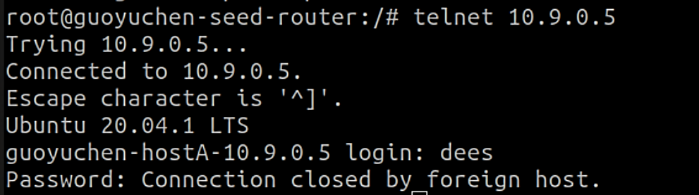

ping from 10.9.0.5 to google.com is accepted.

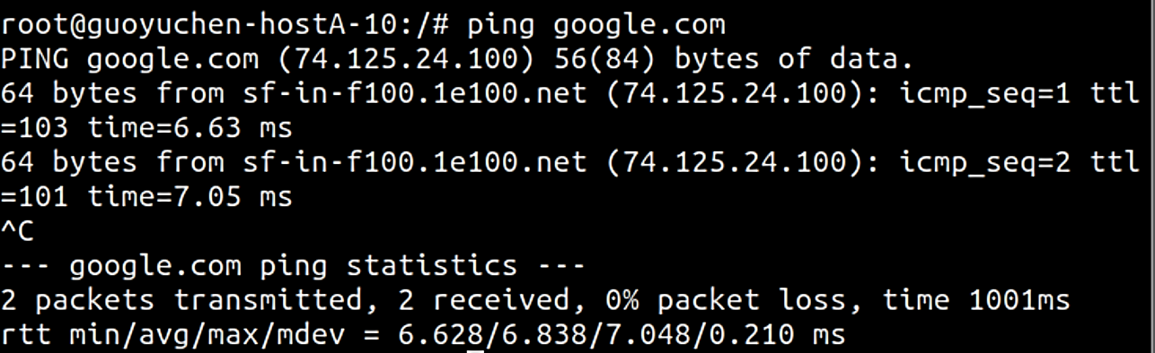

ping from 192.168.60.5 to 192.168.60.7 is accepted.

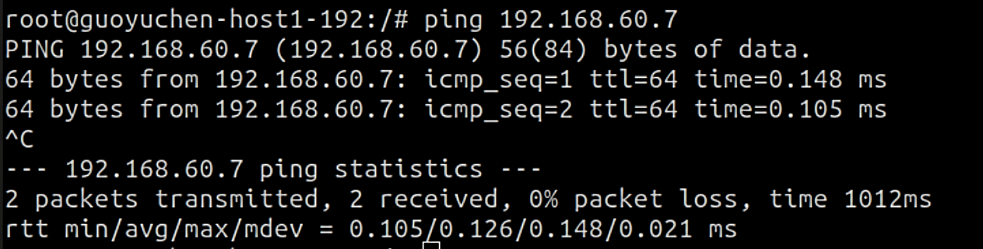

### Task 2.C: Protecting Internal Servers

**// Set default FORWARD policy to DROP. Since other traffic between internal and external networks is prohibited.**

iptables -P FORWARD DROP

**// Outside hosts can only access the telnet server on 192.168.60.5.**iptables -A FORWARD -i eth0 -p tcp -d 192.168.60.5 --dport 23 -j ACCEPT  
iptables -A FORWARD -i eth1 -p tcp -s 192.168.60.5 --sport 23 -j ACCEPT

* Outside hosts can only access the telnet server on 192.168.60.5, not the other internal hosts.

From 10.9.0.5

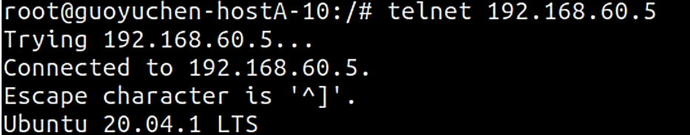



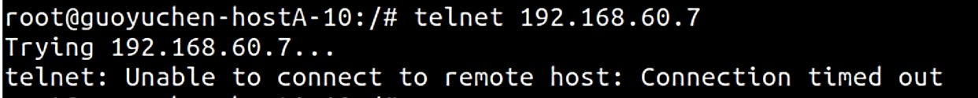

* Internal hosts can access all the internal servers.

From 192.168.60.5

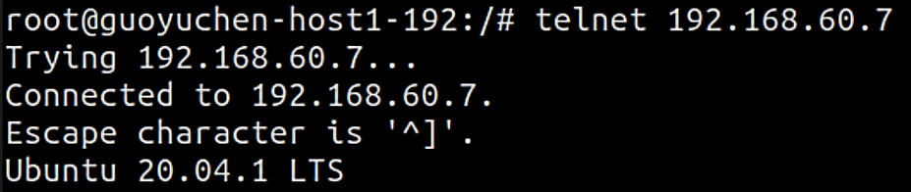

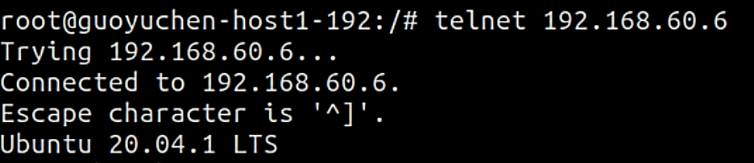

* Internal hosts cannot access external servers.

From 192.168.60.5

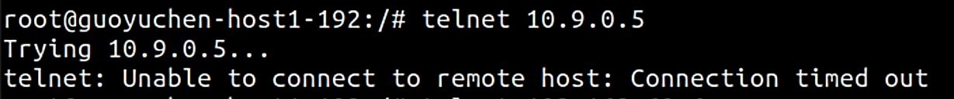

## Task 3: Connection Tracking and Stateful Firewall

### Task 3.A: Experiment with the Connection Tracking

#### ICMP experiment

* Protocol of the connection -> ICMP
* **timeout: how long the connection state is kept. -> 30 seconds**
* src: Source IP address -> 10.9.0.5
* dst: Destination IP address -> 192.168.60.5
* icmp-type: echo request (8)
* what we expect of return packets: the echo reply message from 192.168.60.5

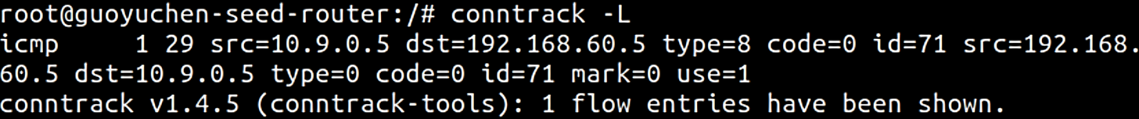

#### UDP experiment

* Protocol of the connection -> UDP
* **timeout: how long the connection state is kept. -> 30 seconds**
* src: source IP address -> 10.9.0.5
* dst: destination IP address -> 192.168.60.5
* sport: source port -> 42465
* dport: destination port -> 9090
* [UNREPLIED]: there’s no return traffic for this connection.
* what we expect of return packets: message from 192.168.60.5 at port 9090

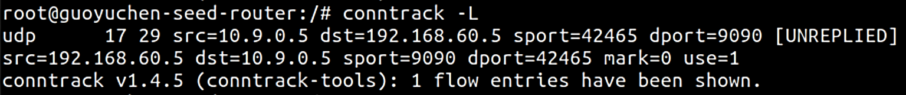

#### TCP experiment

* Protocol of the connection -> TCP
* **timeout: how long the connection state is kept. -> 43200** **seconds**
* state of the connection: ESTABLISHED
* src: source IP address -> 10.9.0.5
* dst: destination IP address -> 192.168.60.5
* sport: source port -> 44476
* dport: destination port -> 9090
* what we expect of return packets: message from 192.168.60.5 at port 9090

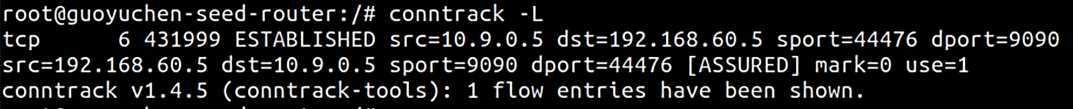

### Task 3.B: Setting Up a Stateful Firewall

**// previous added rules**iptables -P FORWARD DROP  
iptables -A FORWARD -i eth0 -p tcp -d 192.168.60.5 --dport 23 -j ACCEPT  
iptables -A FORWARD -i eth1 -p tcp -s 192.168.60.5 --sport 23 -j ACCEPT

**// Newly added rules**

**// Allow existing connections**iptables -A FORWARD -p tcp -m conntrack --ctstate ESTABLISHED,RELATED -j ACCEPT

**// Allow internal hosts to connect to external hosts for the first time**iptables -A FORWARD -i eth1 -p tcp --syn -m conntrack --ctstate NEW -j ACCEPT

Internal hosts can visit external servers.

192.168.60.6 can connect to 10.9.0.5.

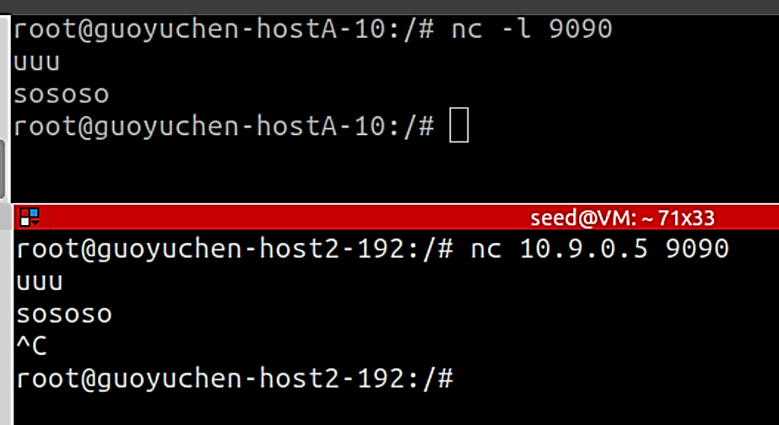

To implement without Connection Tracking: Need to explicitly allow traffic for both outgoing and incoming packets based on the source and destination.

**Stateful Filtering** (With Connection Tracking)

* **Advantages**:
  + More specific and fine-grained rules and policies can be enforced.
  + Can maintain state information about connections, which can be used to distinguish between legitimate, established connections and unauthorized or malicious traffic, etc.
* **Disadvantages**:
  + Consumes more system resources to maintain state information for each connection.
  + It brings complexity to the firewall configuration, which makes managing and troubleshooting rules related to established connections and connection states more demanding.

**Stateless Filtering** (Without Connection Tracking)

* **Advantages**:
  + Consumes fewer system resources because it doesn't maintain connection state information. Reduces the overhead.
  + Simpler to configure and maintain.
* **Disadvantages**:
  + Configuring rules for more complex setups can be limited since it does not inspect states of traffic.
  + Maintaining the rules becomes harder as the number of allowed connections grows.

## Task 4: Limiting Network Traffic

1. with the second rule: the speed is normal at first, but getting slower after 5 packets transmitted. We see from the terminal that 76% of the packets are lost.

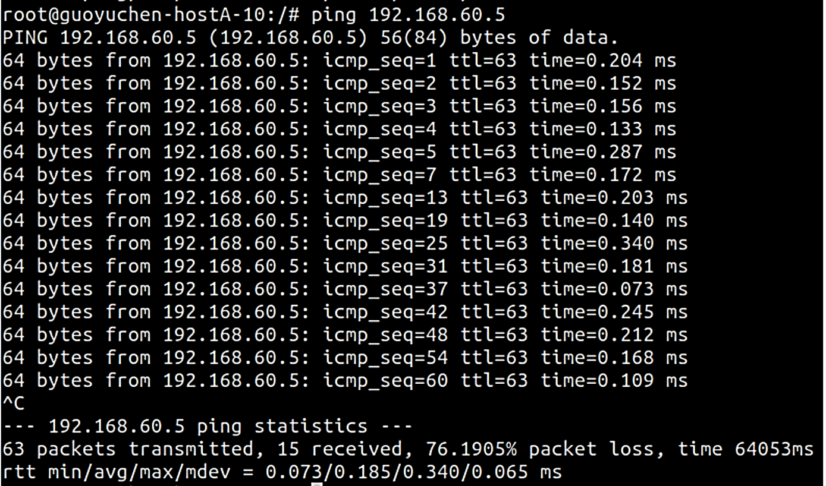

1. without the second rule: does not limit traffic.

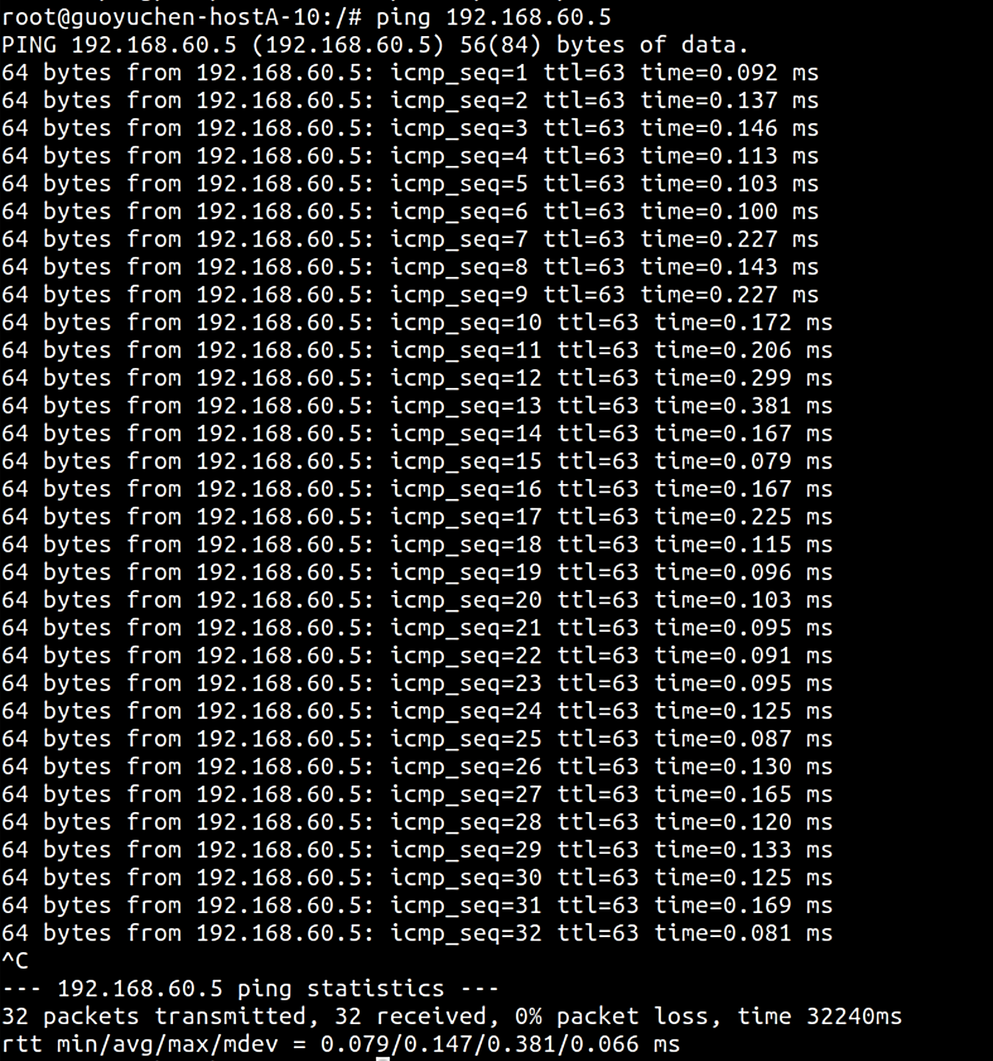

Thus the second rule is needed. Because the kernel will process the packages that are out of the limit according to the default policy, which is ACCEPT if we don’t apply the second rule.

## Task 5: Load Balancing

### Using the nth mode (round-robin).

Redirect traffic at every 1/2/3 packages.

iptables -t nat -A PREROUTING -p udp --dport 8080 -m statistic --mode nth --every 3 --packet 0 -j DNAT --to-destination 192.168.60.5:8080  
iptables -t nat -A PREROUTING -p udp --dport 8080 -m statistic --mode nth --every 2 --packet 0 -j DNAT --to-destination 192.168.60.6:8080  
iptables -t nat -A PREROUTING -p udp --dport 8080 -m statistic --mode nth --every 1 --packet 0 -j DNAT --to-destination 192.168.60.7:8080

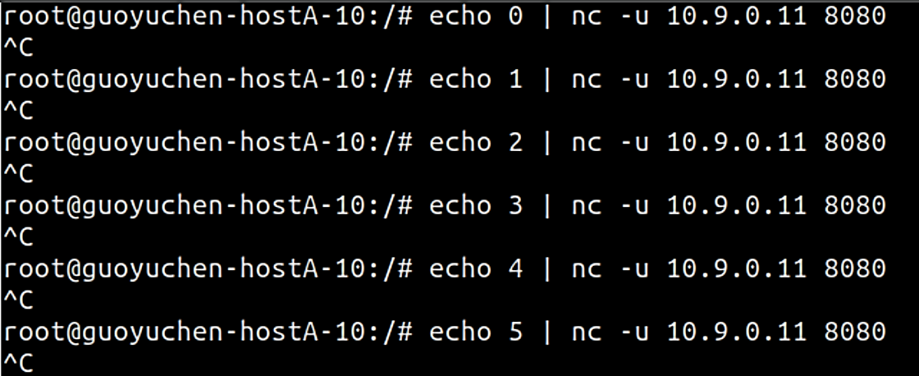10.9.0.5

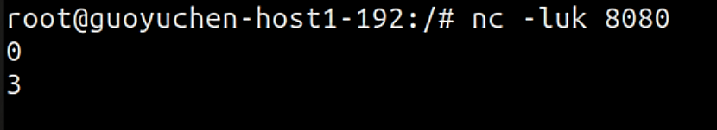192.168.60.5

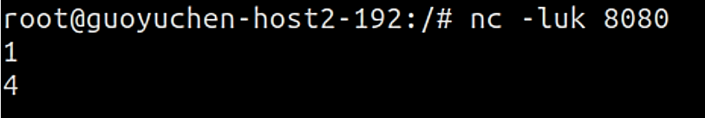192.168.60.6

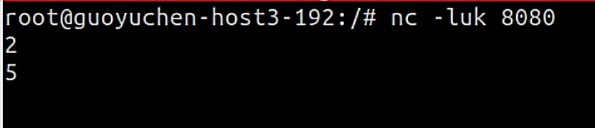192.168.60.7

Thus each host gets equal amount of messages.

### Using the random mode.

Probability set to 0.33 to balance between 3 servers.

iptables -t nat -A PREROUTING -p udp --dport 8080 -m statistic --mode random --probability 0.33 -j DNAT --to-destination 192.168.60.5:8080  
iptables -t nat -A PREROUTING -p udp --dport 8080 -m statistic --mode random --probability 0.33 -j DNAT --to-destination 192.168.60.6:8080  
iptables -t nat -A PREROUTING -p udp --dport 8080 -m statistic --mode random --probability 0.33 -j DNAT --to-destination 192.168.60.7:8080

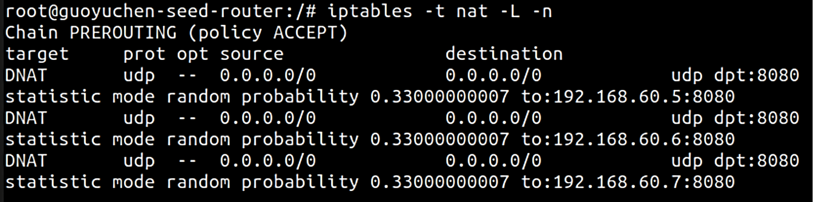

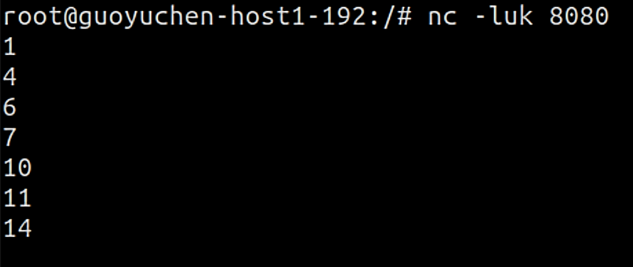192.168.60.5

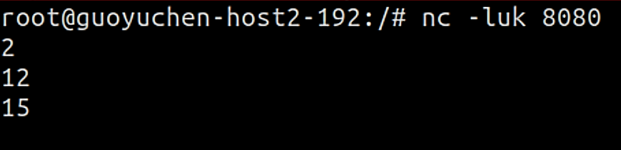192.168.60.6

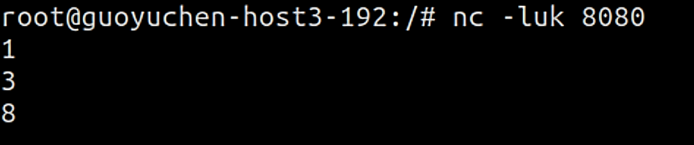192.168.60.7

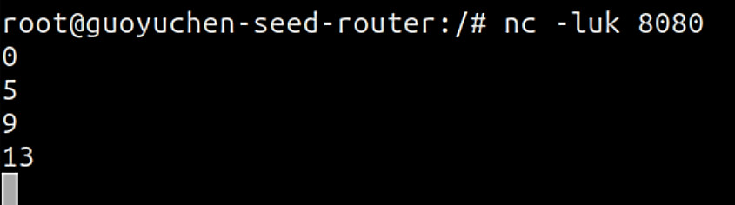10.9.0.11

Traffic is redistributed among 4 hosts.